# Overview

This guided practice will walk you through the setup of the virtual machine that you will use for the remainder of this course.

# Objectives

Install Server 2019 to support Hyper-V

## Skills Reviewed

* Installing Applications
* Changing the computer name
* Configuring common settings in Windows

## New Skills

* Updating PowerShell
* Issuing PowerShell commands
* Activating a computer

# Initial Conditions

* A host machine with Windows Server 2019 Datacenter installed

# Final Conditions

* The VCastle virtual machine configured to support the requirements of the course.

# Instructions

## Server Configurations

In this section, you will configure additional settings to support the class exercises.

### Network Configuration

1. In your assigned VCASLTE POD, click on **client1**, this system is referred to as **VMHost** throughout this course. On **VMHost**, log in as **Administrator** with the password of **Password1**. Do not change this password as it will be used in various scripts in this course.
2. **Rename** your network adapters to **LAN1** and **LAN**.
3. **Disable** the **LAN1** adapter.
4. **Verify** your **network** **settings** and that your virtual **machine can** **reach** the **Internet.**
5. **Rename** your **computer** to **Lastname-VM-Host** where **Lastname** is your last name with no spaces. (e.g. If your last name was Smith, then ***Smith*-VM-Host** would be your host name)
6. **Set** the **time** **zone** to the **correct** **time** **zone** if necessary.

### Usability Settings

1. **Update** **PowerShell** **help.**
   1. **Open** elevated **PowerShell** session by right clicking **Start** and selecting **Windows PowerShell (Admin)**.
   2. Enter **Update-Help**. The output will show some error messages that indicated **Update-Help** failed. These two messages are expected.

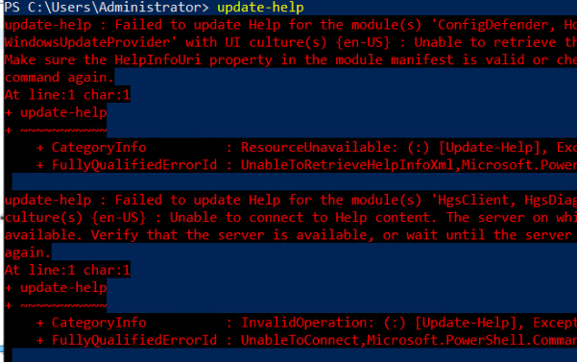

1. **Download** and **Install** the latest version of **Chrome** or **Edge** browser and **set** it **as** the **default** browser if not already added. Chrome is already installed but may not be the most recent version. See <https://www.google.com/chrome/update/> for updating Chrome.

## Activate a Computer

**Note**: The Windows VM at ECPI were installed as part of the ECPI volume licensing plan and must be activated from a key management server. The steps below walk you through the activation process.

* + 1. Log in to the VM using an admin user.
       1. Open a command prompt by right clicking **Start** and selecting **Windows PowerShell (Admin).**

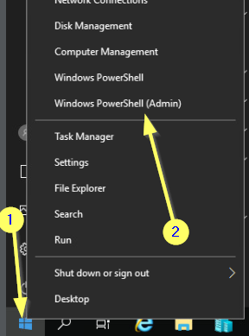

* + - 1. To identify the KMS server for the computer, enter the following command **slmgr /skms adminkms1.ecpivab.edu** and press **Enter**. You should get the below message:

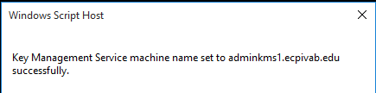

* + - 1. To activate the computer, enter the following command **slmgr /ato** and press **Enter**. You should get a message like the following:

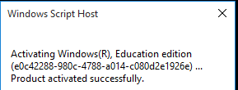

* + - 1. To verify the computer is activated, enter the following command **slmgr /dlv.**

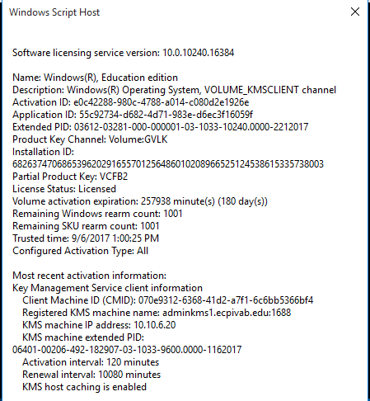

* + - 1. Enter the following command **slmgr /dli** and compare the output to the output of the **slmgr /dlv** command. What is the difference? How many days remain on your activation?

## Configuring Windows Server 2019 as a Virtualization Server

To enable virtualization, on a Windows Server, you need to install the Hyper-V role. To do this, perform the following:

1. **On** your **VMHost** machine.
2. The **Hyper-V** role was added to this system already. Open Hyper-V Manager by:
   1. On **Server Manager** select **Tools** -> **Hyper-V Manager**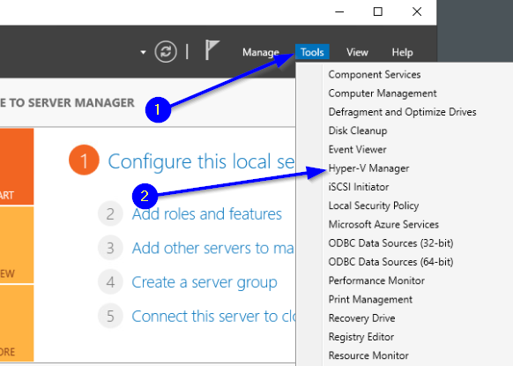
3. **Pin** the **Hyper-V Management** console to the **taskbar.**
4. Open a **PowerShell session** and change the execution policy to unrestricted by typing the following command:

Set-ExecutionPolicy Unrestricted

When prompted, enter **A** for **Yes to all**.

# Submission Requirements

**Note**: PowerShell script will be run in various exercises to assist you with verifying that all portions of the Guided Practice are completed, particularly the portions that other Guided Practice need as prerequisites.

1. **On** your **VMHost** system**, create** a **folder** in the root of your **C:\** named **Scripts**. Log into Canvas and access this course. **Download** the **grading** **script** from the assignment page to the **C:\Scripts** folder.
2. Check your lab by running the following command:

Invoke-Pester -Path C:\Scripts\GP01-Lab_Setup_VCastle.test.ps1

**Note**: You will see a security warning when running the script. Enter **R** to run the script.

If you want to see more detail, add **-Output Detailed** to the command. This may assist you with troubleshooting

Invoke-Pester -Path C:\Scripts\GP01-Lab_Setup_VCastle.test.ps1 -Output Detailed

1. You should not see any red in the output. Red in the PowerShell way of telling you that an error condition exists. Most of the time, the output will tell you what is wrong. If it is not obvious, contact your teacher and ask for assistance. You will be learning PowerShell during this term. **Correct** any **errors** you may have and run the script until all the output has no red. You should see the output like the images below.

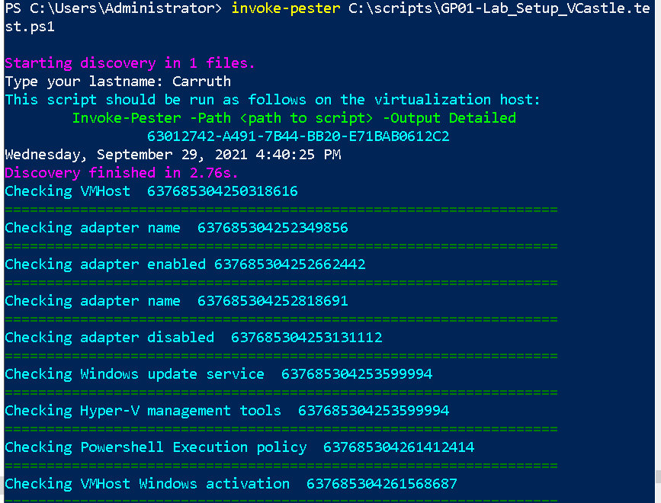

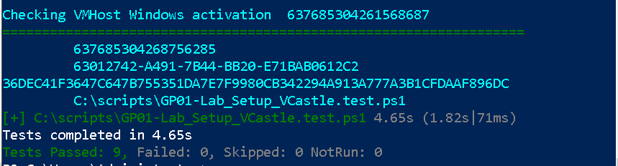

1. Capture a snippet that shows the PowerShell Command and all its output. If you must use more than one snippet to capture the output, you must have at least **one line of overlap** in the snippets. The text in the snippets **must be legible** when pasted into the Word document. Paste the snippet(s) into the **VMHostSetup_*FirstName*_*Lastname*.docx** where ***FirstName*** is your first name and ***LastName***is your last name
2. **Upload** your **VMHostSetup_*FirstName*_*Lastname*.docx** report in the submission area for the assignment.